Software Requirements Specification

for

Library Management System

Version 2.1.1 approved

Prepared by Group 4

HOÀNG ANH VŨ

TRIỆU QUỐC DOANH

NGUYỄN TIẾN HƯNG

NGUYỄN ĐẶNG MINH THUẬN

*May 24,2021*

Table of Contents

**Revision** **History..………………………………………………………………………………………....ii**

1 Introduction 1

1.1 Purpose 1

1.2 Document Conventions 1

1.3 Project Vision and Product Scope 1

1.3.2 Product Scope 1

1.4 References 1

2 Overall Description 2

2.1 User Classes and Use Case diagram 2

2.1.1 < Librarian> 2

2.1.2 < Members > 2

2.2 Use Case diagram 2

2.3 Operating Environment 4

2.4 Design and Implementation Constraints 4

2.5 User Documentation 4

2.6 Assumptions and Dependencies 4

3 Functional Requirements / Use case details 4

3.1 LR: Librarian 4

3.1.1 LR-F01: Issued a book to the member 4

3.1.2 LR-F02: View category of book 4

3.1.3 LR-F03: Check out book 5

3.1.4 LR-F04: Add book 5

3.1.5 LR-F05: Edit book 5

3.1.6 LR-06: Search a book 5

3.2 MB: Member 5

3.2.1 MB-F01: View category of book 5

3.2.2 MB-F02: View list of books depend on category 6

3.2.3 MB-F03: Own an account 6

3.2.4 MB-F04: View book issued 6

3.2.5 MB-F05: Request for a new book 6

3.2.6 MB-F06: View history of issued books 7

3.2.7 MB-F07: Search a book 7

4 External Interface Requirements 7

5 Other Nonfunctional Requirements 8

5.1 Performance requirement 8

5.2 Security: 8

5.3 Usability: 8

6 Business Rules 8

# Introduction

## Purpose

The main objective of this document is to illustrate the requirements of the project Library Management system. The document gives the detailed description of the both functional and non-functional requirements proposed by the client.The purpose of this project is to provide a friendly environment to maintain the details of books and library members.The main purpose of this project is to maintain easy circulation system using computers and to provide different reports. This project describes the hardware and software interface requirements using ER diagrams and UML diagrams

## Document Conventions

* Entire document should be justified
* Convention for Main title
  + Font face: Times New Roman
  + Font style: Bold
  + Font Size: 14
* Convention for Sub title
  + Font face: Times New Roman
  + Font style: Bold
  + Font Size: 12
* Convention for body
  + Font face: Times New Roman
  + Font Size: 12

## Project Vision and Product Scope

#### Vision Statement

The library book management system aims to help readers find clearer information about a book including author, date of publication, edition. The Library envisions that it will fulfill its unique role as a major contributor to the academic, cultural, and social development of the university community. We want to bring a system that is convenient for everyone by applying modern technologies into the system.

### Product Scope

Library Management System is basically updating the manual library system into an Internet based application so that the users can know the details of their accounts, availability of books and maximum limit for borrowing. The project is specifically designed for the use of librarians and library users. The product will work as a complete user interface for library management process and library usage from ordinary users. Library Management System can be used by any existing or new library to manage its books and book borrowing, insertion and monitoring. It is especially useful for any educational institute where modifications in the content can be done easily according to requirements

## References

# Overall Description

## User Classes and Use Case diagram

### < Librarian>

The features that are available to the Librarian are:

* ***LR-F01****:* Issue a book to the member.
* ***LR-F02****:* View categories of books
* ***LR-F03****:* Check out books
* ***LR-F04****:* Add book
* ***LR-F05****:* Edit book
* ***LR-F06****:* Search a book

### < Members >

The features that are available to the Members are:

* ***MB-F01:*** View categories of books
* ***MB-F02:*** View List of books depend on category
* ***MB-F03:*** Own an account
* ***MB-F04:*** View book issued
* ***MB-F05:*** Request for a new book
* ***MB-F06:*** View books
* ***MB-F07:*** Search a book

## Use Case diagram

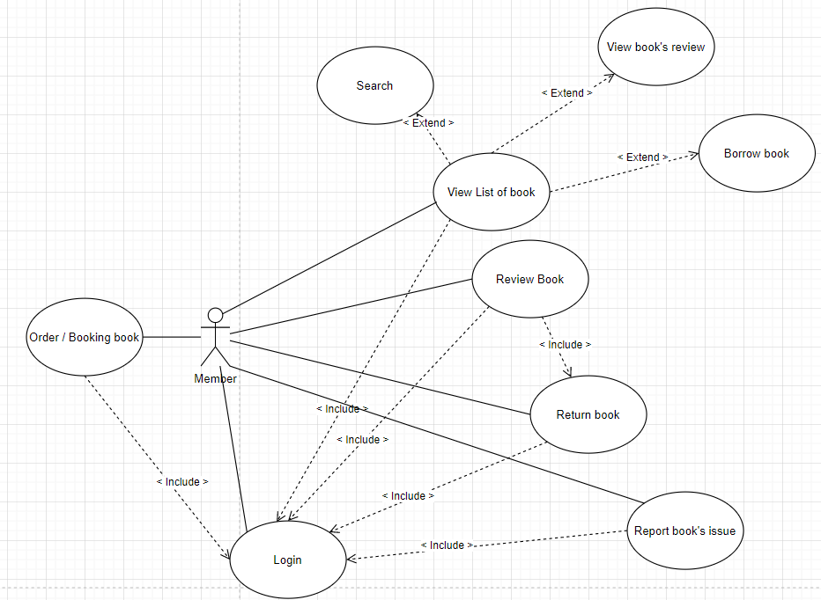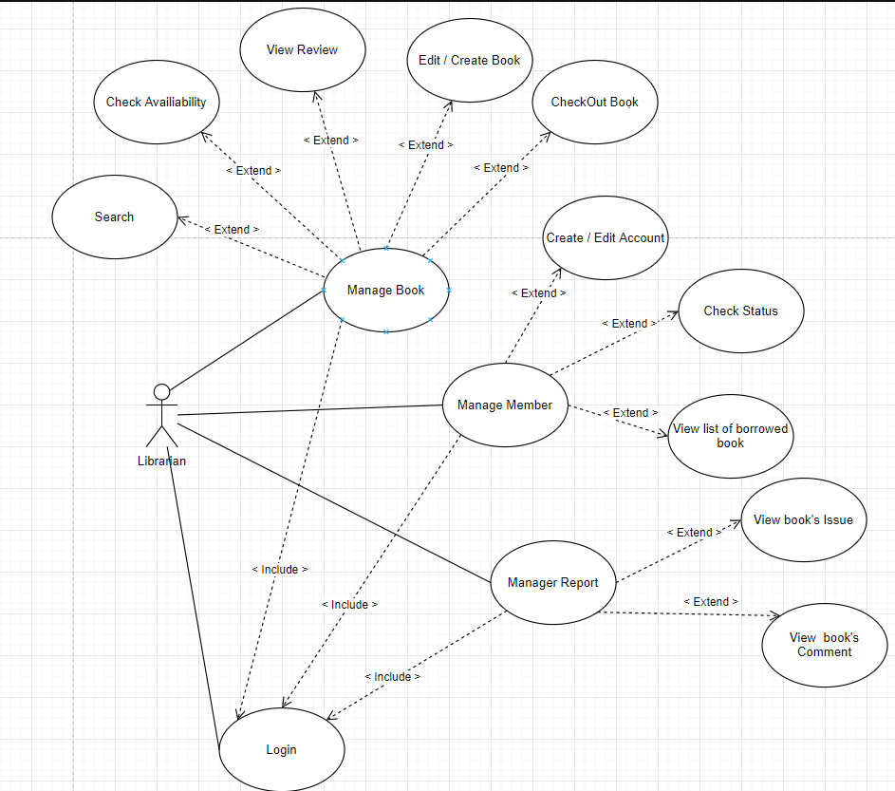

## Operating Environment

The product will be operating in windows environment. The Library Management System is a website and shall operate in all famous browsers, for a model we are taking Microsoft Internet Explorer, Google Chrome, and Mozilla Firefox.Also it will be compatible with the IE 6.0. Most of the features will be compatible with the Mozilla Firefox & Opera 7.0 or higher version. The only requirement to use this online product would be the internet connection. The hardware configuration includes Hard Disk: 40 GB, Monitor: 15” Color monitor, Keyboard: 122 keys. The basic input devices required are keyboard, mouse and output devices are monitor, printer etc.

## Design and Implementation Constraints

Any update regarding the book from the library is to be recorded to have update & correct values, and any fine on a member should be notified as soon as possible and should be correctly calculated.

## User Documentation

The User documentation will include:

* User will be able to download User Manual from website’s help section
* Video tutorials will be available for further guidance
* Help Button will be available everywhere

## Assumptions and Dependencies

* All the data entered will be correct and up to date.
* Able to backup and restore databases
* Microsoft SQL server to store the database.
* This software package is developed using JAVA/ ASP .NET
* The system is completed and fully packaged before being delivered to the customer.
* Use the resources available from the library.
* During project implementation, customers can change some requirements within the permitted scope and consent of project manager.

# Functional Requirements / Use case details

## LR: Librarian

### LR-F01: Issued a book to the member

* State: Searched the book user wants to issued.
* Input: Click on the book user wants.
* Output: Issued the book(s) to user.
* Processing: if selected book is available then book will be issued, else error will be displayed.

### LR-F02: View category of book

* Input: Click on category list on the taskbar.
* Output: Display the list of categories.

### LR-F03: Check out book

* Input: Return the book to the library.
* Output: The issued list will be updated and the returned book will be listed out.

### LR-F04: Add book

* Input: Enter the details of the books such as name, author, edition, quantity.
* Output: The book is added successfully to the system.
* Exception: If librarian enter blank for details such as name, author, edition, quantity then there will be an error message.
* Business rules: the bookID must follow the format AA000 (AA is alphabet, 000 is integer).

### LR-F05: Edit book

* Input: Enter the name of the book on the text box and click on that book, then the details that you want to edit.
* Output: Update the list of books successfully.

### LR-06: Search a book

* Input: Enter the name of the book on text box then click “Search” button.
* Output: Display the details of the existing book such as name, author, edition, quantity and issued status.
* Exception: if librarian enter the book’s name that does not exist in library then an error message will be displayed. If librarian enter blank, list of all books will be display.

## MB: Member

### MB-F01: View category of book

* Input: Click on category list on the taskbar.
* Output: Display the list of categories.

### MB-F02: View list of books depend on category

* Input: Click on the category on taskbar, then the category list will be displayed. After that, choose the specific category.
* Output: Display the list of books depend on category.

### MB-F03: Own an account

#### Register:

* Input: Detail about the user (at least username and password, other information can be updated later).
* Output: An account is registered.
* Exception: Input blank or special characters will result in an error message.
* Business rules: username must be a string from 4 to 20 characters (not include special character). Password must be a string from 6 to 12 characters (not include special character).

#### Login:

* Input: Enter username and password then click the “Log In” button.
* Output: Display the main interface of the system.
* Exception: Input blank or special characters will result in an error message.

### MB-F04: View book issued

* Description: Display the list of issued books that user borrowed.
* Input: Click on the “Issued Books” on taskbar.
* Output: Display list of books currently issued.

### MB-F05: Request for a new book

* State: Search the book user wants to issue.
* Input: Enter the name of the book that member wants to borrow. Click on the book user wants.
* Output: Request successfully then borrow the book.
* Exception: If the book is not available (not in the library) then display an error message.
* Business rules: one member can only borrow maximum 5 books at one time. Books must be returned in 15 days or they must pay the fine.

### MB-F06: View history of issued books

* Description: Display a list of issued books that user have borrowed of all time.
* Input: Click on the “History” on taskbar.
* Output: Display the list of issued books of all time.

### MB-F07: Search a book

* Input: Enter the name of the book on text box then click “Search” button.
* Output: Display the details of the existing book such as name, author, edition, quantity and issued status.
* Exception: if librarian enter the book’s name that does not exist in library then an error message will be displayed. If librarian enter blank, list of all books will be display.

# External Interface Requirements

# Other Nonfunctional Requirements

## Performance requirement

## Security:

## Usability:

# Business Rules

Appendix A: Analysis Models

